**INTRODUCTION**

Now a days we released the importance of the natural resources and as we were seriously trying to preserve them effectively. As we can’t be careful all the time we can alternatively use the present technology to build the smart systems. These smart systems can help use to remind things at the time we need. As result we are going to take the task of water control system in building. Here firstly, we are going to control the water flow in the apartment by using the rate of inflow and the outflow of the water in the tank. We are going to calculate the rate of inflow and rate of outflow in the tank. If the rate of inflow is greater than the rate of outflow the level of the water in the tank increases and if the rate of inflow is lesser than the rate of outflow, then the level of the water in the tank is going to be decreased. We are going to have a display of the tank level in the front panel we can clearly understand what’s going on in the tank. And we are also adding the additional feature to the program by showing the led and alarm. If the water level is less than 10 liters, then red led and alarm will be ringing. If the water level is filled up, then if it reaches the 90 liters also a green led is on. The inputs and the outputs both can be displayed in the front panel. The inputs can be changed randomly. We will have two exception cases like water level becoming less than zero and the water level becoming more than 1000 liters, these two cases can be controlled by cutting the range to 0 and 1000 in the cases. i.e., if the water level is less than or equal to zero then the fixed value zero will be displayed in the tank as water level can’t be zero. In the same way if the water level reaches more than the 1000 liters then it will be fixed to 1000 liters as a result, we can come out of the two error cases. Addition to this we are going to control the water inflow using a switch. Here if the water level is more than the 95 percent then the switch will be turned off immediately. If we add these to the project, then it converts into the automatic system.

The major tasks were the calculation of the water level in the tanker and displaying the level based on the output the increment and decrement of the water in the tank. The final front panel will show the water level in the tank, a rate of inflow and rate of outflow. The inputs we are taking are the rate of flow of water into the tank and the rate of the water flowing out of the tank. The output is the water level indication in the tank. Additionally, we are going to see the display of the led based on the water level in the tank, because it makes our task more clear and easier. The improvements of our project are it can be automated and if the water level is below 10 liters then automatically the switch need to be on and if the water level reached the 90 liters then it should automatically get off along with the manual switches to control. As we all knew we will be busy in our daily works and to reduce the effort we use the automated devices. Even though the power consumption is somewhat more than usual we prefer then because the percentage of error is less and more accurate. It reduces the human effort and we can save a lot of water and power. If the machines are automated, then the effort also reduces and we can do other things instead of the doing the routine and boring things.

**METHODOLOGY:**

This prototype is designed using the following steps

**2.1 Description on adapted method:**

Here we are going to control the water level in the tank based on the water present in the tank. We are going to take the inflow and outflow of the water and the capacity of the tank into the consideration. The output will be the automated switch on and off the tank and addition to that we add led to display the level of the tank. The major tasks were the calculation of the water level in the tanker and displaying the level based on the output the increment and decrement of the water in the tank. The final front panel will show the water level in the tank, a rate of inflow and rate of outflow. The inputs we are taking are the rate of flow of water into the tank and the rate of the water flowing out of the tank. The output is the water level indication in the tank. Additionally, we are going to see the display of the led based on the water level in the tank, because it makes our task more clear and easier. The improvements of our project are it can be automated and if the water level is below 10 liters then automatically the switch need to be on and if the water level reached the 90 liters then it should automatically get off along with the manual switches to control. As we all knew we will be busy in our daily works and to reduce the effort we use the automated devices. Even though the power consumption is somewhat more than usual we prefer then because the percentage of error is less and more accurate. It reduces the human effort and we can save a lot of water and power. If the machines are automated, then the effort also reduces, and we can do other things instead of the doing the routine and boring things

**2.2 Description of flow of Program with flow chart:**

*ONE NUMERIC CONTROL AND TWO INDICATORS*

*CHEKING WATER LEVEL AND DISPLAY*

*CALUCLATION OF THE WATER LEVEL*

BASED ON THE WATER LEVEL ON/OFF OF THE MOTOR

*IF OUTFLOW IS MORE THEN WATER LEVEL WILL BE INCRESEAD*

*ELSE THE SAME WATER LEVEL WILL BE DISPLAYED*

**Structures and Elements used in the design process:**

1. Numeric control

2. Case structure

3. While loop

4. Booleans (stop button, LED)

5. Mathematical operators (equal to, multiplication, addition, subtraction)

6. Tank

7. In range and coerce function

**TECHNICAL DESCRIPTION:**

1. NUMERIC CONTROL

The **Numeric Control** is a input display which by default is a **numeric** double value and can modified using the up and down arrows next to the display or manually changed by double clicking and inputting the desired value. The **Numeric** Indicator is an output display which will display the value that it receives.

2. CASE STRUCTURE

Case structure contains one or more sub diagrams, or cases, exactly one of which executes when the structure executes. The value wired to the case selector determines which case to execute.

Contains one or more sub diagrams, or cases, exactly one of which executes when the structure executes. The value wired to the case selector determines which case to execute.

|  |  |
| --- | --- |
|  | **Selector label**—Displays the value(s) for which the associated case executes. You can specify a single value or a [range of values](lvhowto.chm::/case_selector_values.html). You also can use the selector label to [specify a default case](lvhowto.chm::/Specify_Default_Case.html). |
|  | **Sub diagram(case)**—Contains the code that executes when the value wired to the case selector matches the value that appears in the selector label. To modify the number or order of sub diagrams, right-click the border of the Case structure and select the appropriate option. |
|  | **Case selector**—Selects which case to execute based on the value of the input data. The input data can be a Boolean, string, integer, enumerated type or [error cluster](lvhowto.chm::/Using_Case_Structures_for.html). The data type you wire to the case selector determines the allowed cases you can enter in the selector label. |

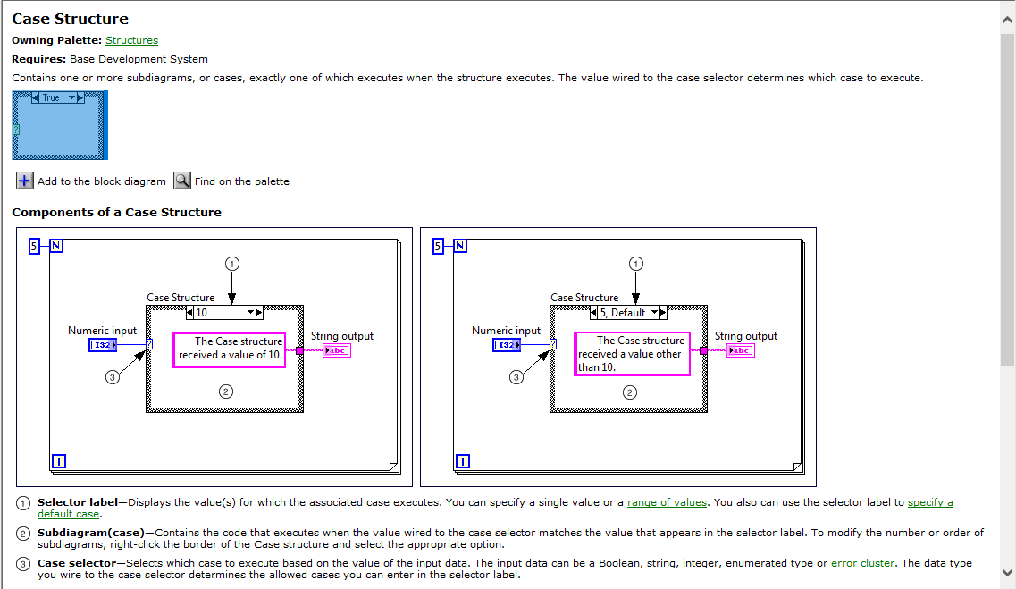

3.WHILE LOOP:

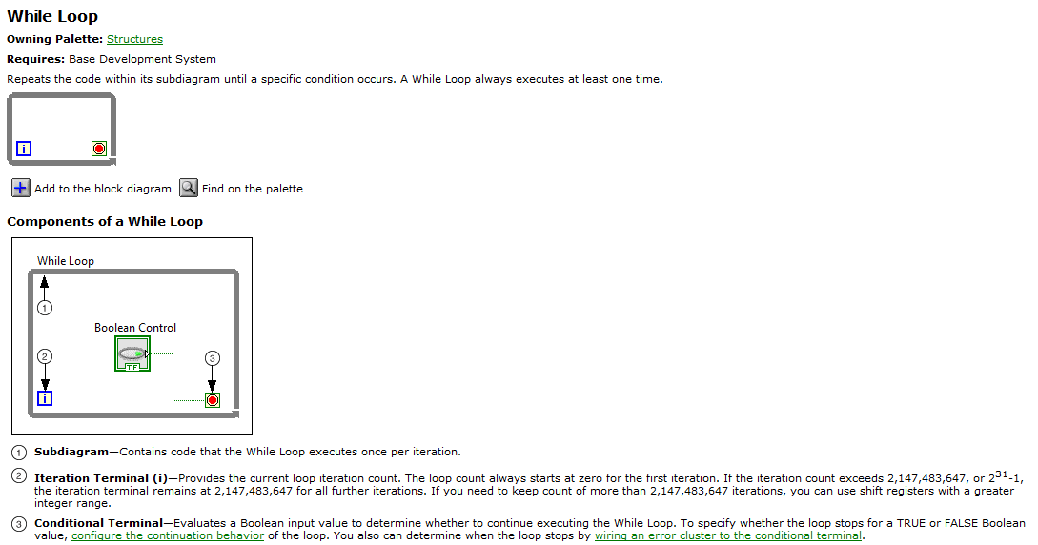

# 

In Range and Coerce Function

**Owning Palette:** [Comparison Functions](glang.chm::/Comparison_Functions.html)

**Requires:** Base Development System

Determines whether **x** falls within a range specified by the **upper limit** and **lower limit** inputs and optionally coerces the value to fall within the range. The function performs the coercion only in [Compare Elements mode](lvconcepts.chm::/Comparison_Funcs.html#Compare_Elements_Mode_Arrays). This function accepts time stamp values if all inputs are time stamp values. You can [change the comparison mode](lvhowto.chm::/Setting_Compare_Functions.html) of this function.

The connector pane displays the default data types for this polymorphic function.

**Experiment and Results**

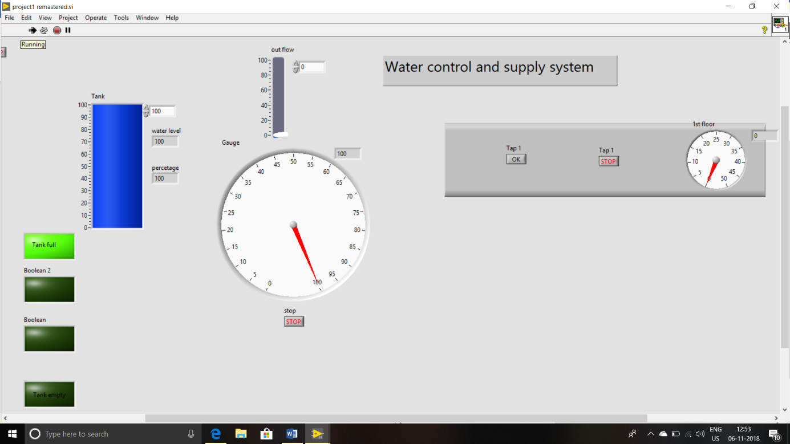

when tank is totally filled green light is glowed and gauge reading is 100.

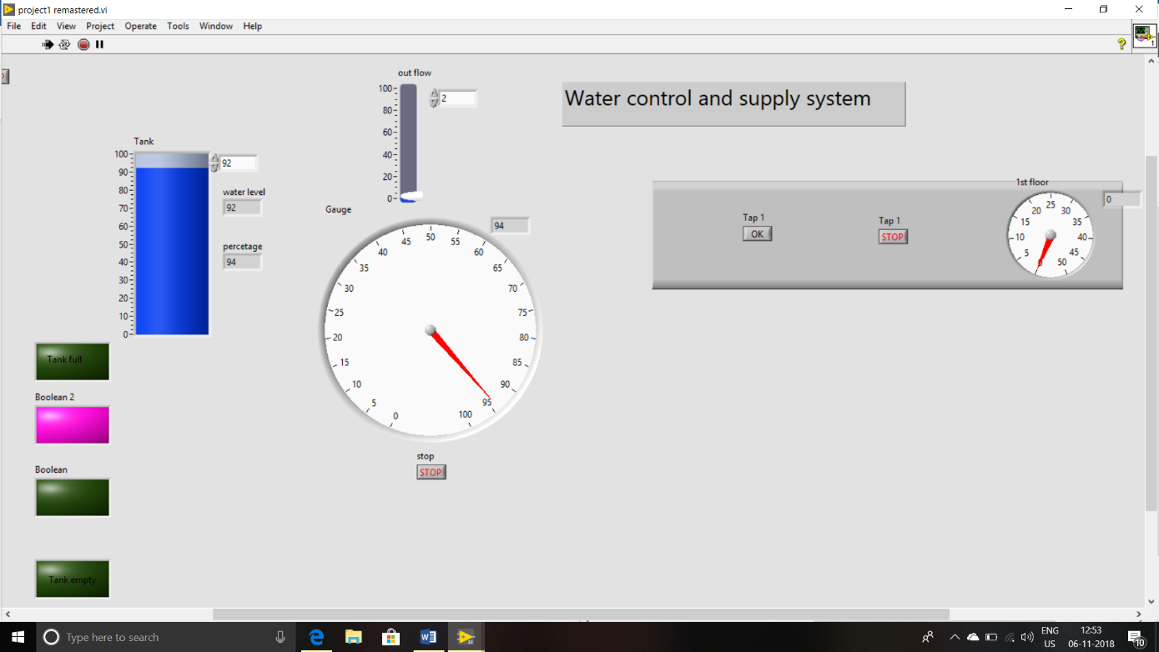

When tank level is in between 50 to 90 pin light is glowed and percentage is shown in led display and gauge

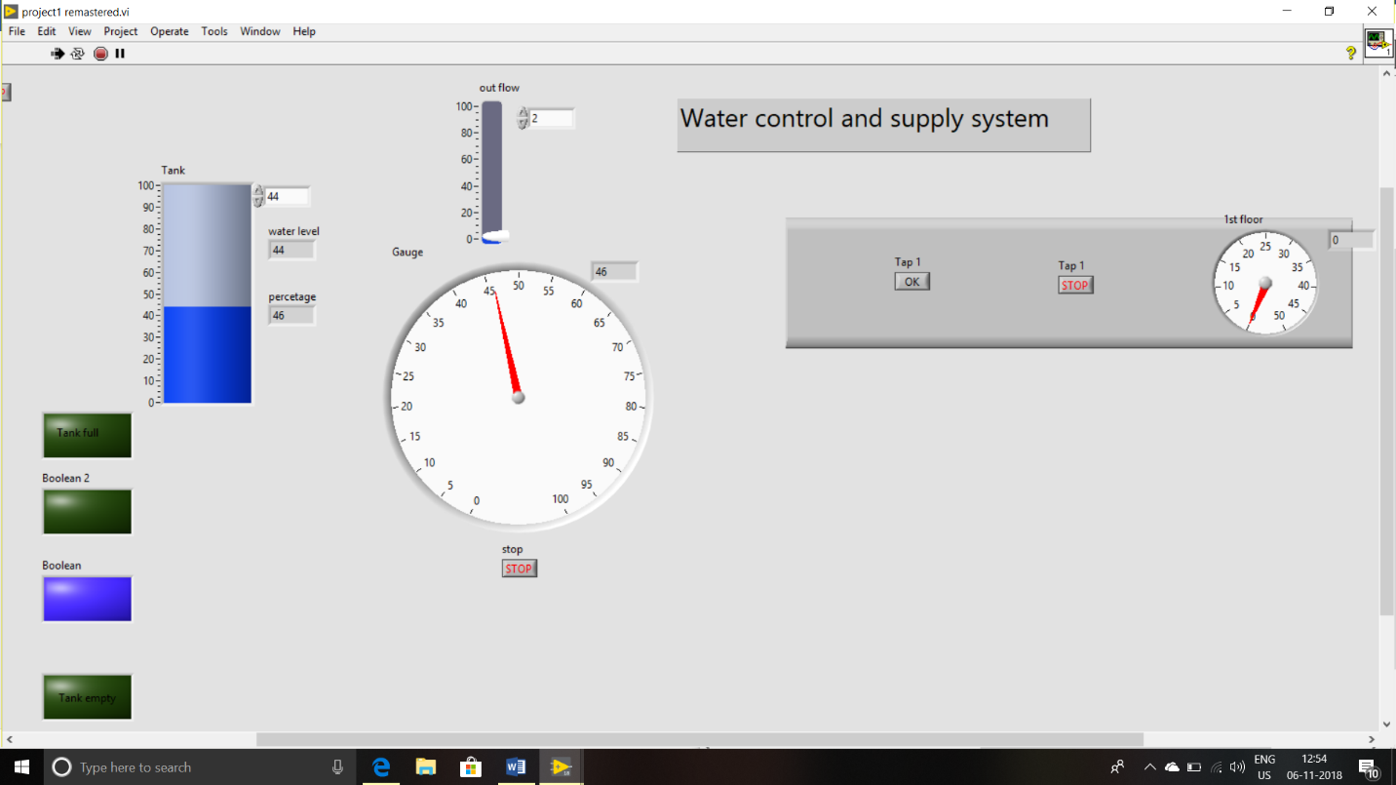

When reading is in between 20 to 50 blue light is glownand the reading is shown I led display and gauge.

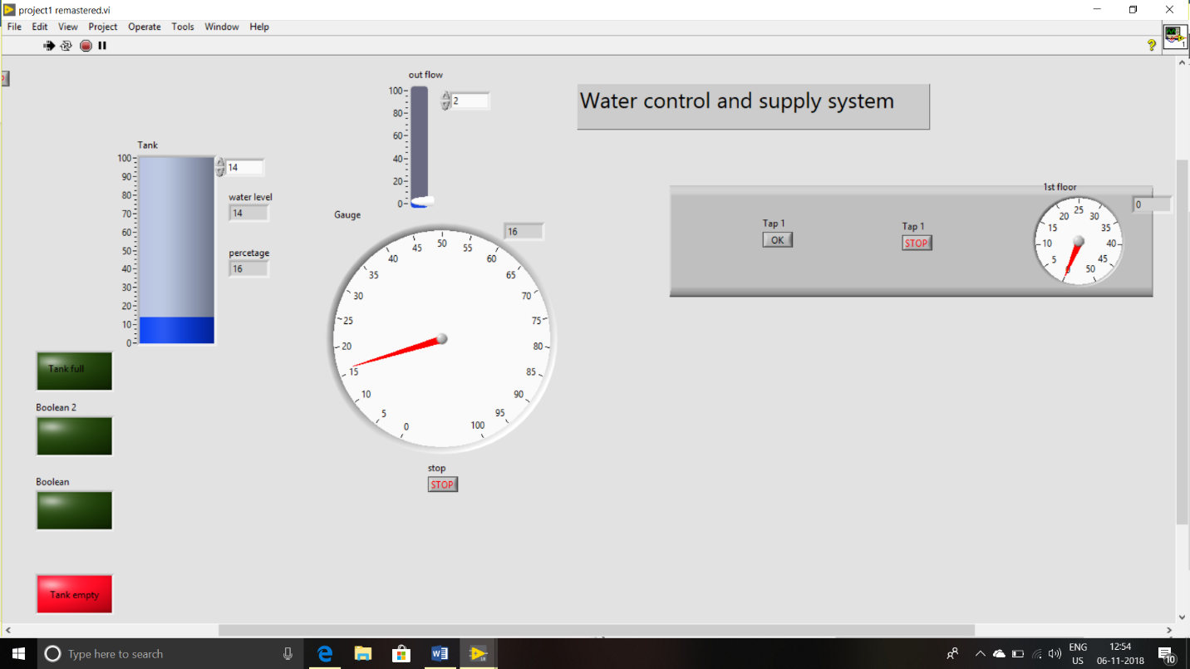

When tank level is lessthan 20% the red light is glown and buzzer will be on. And reading is shown in gauge.

**5. Conclusion and Future Scope:**

Water is one of the most important basic needs for all living beings. But unfortunately, a huge amount of water is being wasted by uncontrolled use. Other water level monitoring systems do exist but lack functionality in terms of being able to monitor and manage multiple sources of water. LabVIEW is ideal for any measurement or control system, integrating graphical tools that facilitate the building of a wide range of applications in less time compared to using other practices. The present system modelling and implementation deals with the automatic motor on and off. If this system is used the water resources can be used more effectively. Lot of power consumption is the major disadvantage. The sensors used will be damaged. The major contribution to the society was we can feel free and relaxed and can-do lot many works. These switching on and off are the routine jobs. If we use these automations, then the natural resources are going to be saved.